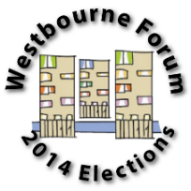
Westbourne Neighbourhood Forum

Application Form for the candidates to the Management Committee

- Full Name: ……………………………………………………………………………………………………..

- Email: ………………………………………………………………………………………………

- Phone number: ………………………………………………………………………………….

- Address: ……………………………………………………………………………………………………………

…………………………………………………………………………………………………………………………..

- Please circle which applies to you:

Resident Representative of a local voluntary or community organisation
Representative of a local statutory service Young person (age 16-21) Local Business

- In no more than 150 words please describe (i) your reasons for applying, (ii) your knowledge, experience and commitment to Westbourne, and (iii) any previous involvement in Westbourne community life. Thank you.

Please return by 8th November 2014
by post to: 88 Church Street, NW8 8ET or email to: monika@pdt.org.uk

